Yarmouk University


Collage of Information Technology
and
Computer Science
Department of Information Systems
Data Science & Artificial Intelligence program

Emotion Recognition Assistant

Fadia Alhajjeh & Rawan Ahmad

Dr. Enas Khashashneh

FIRST TERM 2024
Acknowledgement

Table of content
Introduction
Problem Statement
Project Objectives
Literature Review
Methodology
  - Data Collection
  - Preprocessing
  - Techniques
  - Post-processing
  - Performance Metrics
  - Product
Results and Discussion
Limitations
Conclusion
Future Work
References
Appendix

List of Tables
Table 1
Table 2
Table 3

List of Figures
Figure 1
Figure 2
Figure 3
Figure 4
Figure 5
Figure 6
Figure 7

Abstract
This project focuses on developing an emotion recognition tool to assist individuals with challenges in interpreting emotional cues, such as those with autism, alexithymia, social anxiety, or traumatic brain injury. The tool analyzes emotions from both speech and text, using machine learning models to provide real-time feedback and improve users' emotional understanding. For speech, features like Mel-frequency cepstral coefficients (MFCCs) and spectrograms are extracted and processed using Convolutional Neural Networks (CNNs) and Vision Transformers (ViTs), with enhancements such as Squeeze-and-Excitation (SE) blocks to improve accuracy. For text, pre-trained transformer models like DistilBERT and sequential models like BiLSTM are fine-tuned for sentiment analysis. Additionally, Large Language Models (LLMs) such as OpenAI’s GPT are integrated to offer user-friendly explanations of the detected emotions. This comprehensive approach aims to enhance emotional awareness and social engagement, particularly for individuals facing difficulties in recognizing emotions in social interactions

- Introduction
Understanding and interpreting emotions is a vital skill for effective communication and social interaction. However, for individuals with conditions such as autism, alexithymia, social anxiety, or traumatic brain injury (TBI), this process can be significantly challenging. These difficulties often result in misunderstandings, strained relationships, and social isolation. For example, individuals with autism may struggle to read non-verbal cues, while those with alexithymia might find it difficult to identify emotions, whether in themselves or others. Similarly, social anxiety can lead to overanalyzing emotional signals, and TBI can disrupt emotional recognition processes altogether.
The increasing prevalence of these challenges has highlighted the need for innovative tools that can assist in emotional recognition. Existing technologies often fall short in providing real-time, intuitive solutions that address the diverse needs of these populations. This gap underscores the importance of developing a tool capable of recognizing emotions from both speech and text while offering user-friendly feedback to improve emotional understanding.
This project aims to bridge this gap by leveraging advanced machine learning techniques to develop an emotion recognition tool. By analyzing speech and text data, the tool provides real-time feedback to users, enabling them to better interpret and engage with emotional contexts. Additionally, the integration of Large Language Models (LLMs) ensures that the feedback is presented in a clear and accessible manner. The ultimate goal is to enhance emotional awareness and foster meaningful social interactions for individuals facing these challenges.

- Problem Statement
Recognizing and interpreting emotional cues is a fundamental aspect of effective communication, yet individuals with conditions such as autism, alexithymia, social anxiety, or traumatic brain injury (TBI) often struggle with this skill. These challenges can lead to misunderstandings, hindered social interactions, and feelings of isolation. For instance, individuals with autism may find it difficult to interpret non-verbal cues, while those with alexithymia struggle to identify both their own emotions and those of others. Similarly, social anxiety can result in overanalyzing emotional signals, and TBI can impair emotional processing altogether. Despite advancements in assistive technology, there is a lack of accessible tools that combine real-time emotion recognition from speech and text with intuitive feedback mechanisms to help these individuals navigate emotional contexts more effectively. Addressing this gap is crucial to improving emotional awareness and fostering better social engagement for those affected.

- Project Objectives
- Develop a tool that accurately recognizes emotions from both speech and text.
- Provide real-time feedback to users on detected emotions to improve emotional awareness.
- Assist individuals who struggle with recognizing emotions, such as those with autism, alexithymia, social anxiety, or TBI.
- Integrate a Large Language Model (LLM) to explain detected emotions in a clear and user-friendly manner.
- Design a user-friendly interface that allows seamless interaction with the tool for inputting speech and text data.

- Literature Review
Recent studies that explore various methodologies for Speech Emotion Recognition and Sentiment Analysis, highlighting their relevance and applicability to the goals of the Emotion Recognition Assistant:
In this study [1] the authors focus on Affectiva’s Emotion AI, a real-time emotion recognition system designed to analyze emotions from facial expressions. The technology is particularly helpful for individuals who struggle to interpret emotional cues, such as those with autism. By capturing and analyzing emotional signals in real time, Affectiva provides users with immediate feedback on the emotions expressed during social interactions. This feedback allows users to adjust their responses in real-time, helping them better understand and engage with others. The study highlights how this technology has been used to support individuals who face challenges in recognizing emotions, enabling more effective communication and emotional understanding. This aligns with the goals of the Emotion Recognition Assistant, which aims to provide real-time emotional to individuals with similar difficulties.
This study [2] presents a new way to improve how well speech emotion recognition works by using spectrogram analysis. The authors focus on capturing both frequency and timing features from speech, which helps in understanding the emotions in the audio better. They found that using knowledge transfer techniques allows a model trained on a large dataset to perform better on a smaller, emotion-specific dataset. Their results show that combining different types of information leads to a stronger model that can accurately identify emotions, making a valuable contribution to the field of speech emotion recognition.
This research [3] looks at how multi-task learning (MTL) can make speech emotion recognition systems better. The authors suggest training the model on related tasks, like identifying emotions and recognizing speakers, all at once. This method helps the model learn more detailed features from audio data. The design includes a shared layer for feature extraction and separate branches for each task, which improves the model’s ability to adapt to different situations. The study shows that using the multi-task approach significantly increases emotion recognition accuracy, highlighting the benefits of MTL for creating better speech emotion recognition systems.
This research [4] provides an in-depth exploration of how deep learning techniques are applied to sentiment analysis. The authors focus on models such as LSTMs (Long Short-Term Memory), CNNs (Convolutional Neural Networks), and hybrid models, highlighting their strengths in understanding complex patterns in text data. LSTMs, in particular, are praised for their ability to handle sequential data and capture long-term dependencies, making them highly effective for tracking sentiment shifts in longer texts like conversations or reviews. The review emphasizes that deep learning models have consistently outperformed traditional machine learning methods in sentiment analysis tasks, especially when dealing with large datasets and context-rich language.
This paper [5] explores both lexicon-based and machine learning approaches in sentiment analysis. Lexicon-based methods utilize predefined sentiment lexicons to determine the emotional tone of text, providing a straightforward and interpretable way to classify sentiments. However, they can struggle with contextual nuances, such as sarcasm or subtle emotional variations. In contrast, machine learning approaches leverage statistical models to capture complex patterns in language, often resulting in higher accuracy. The study suggests that a hybrid methodology combining both approaches can enhance sentiment classification effectiveness, addressing the limitations of each while maximizing their strengths.
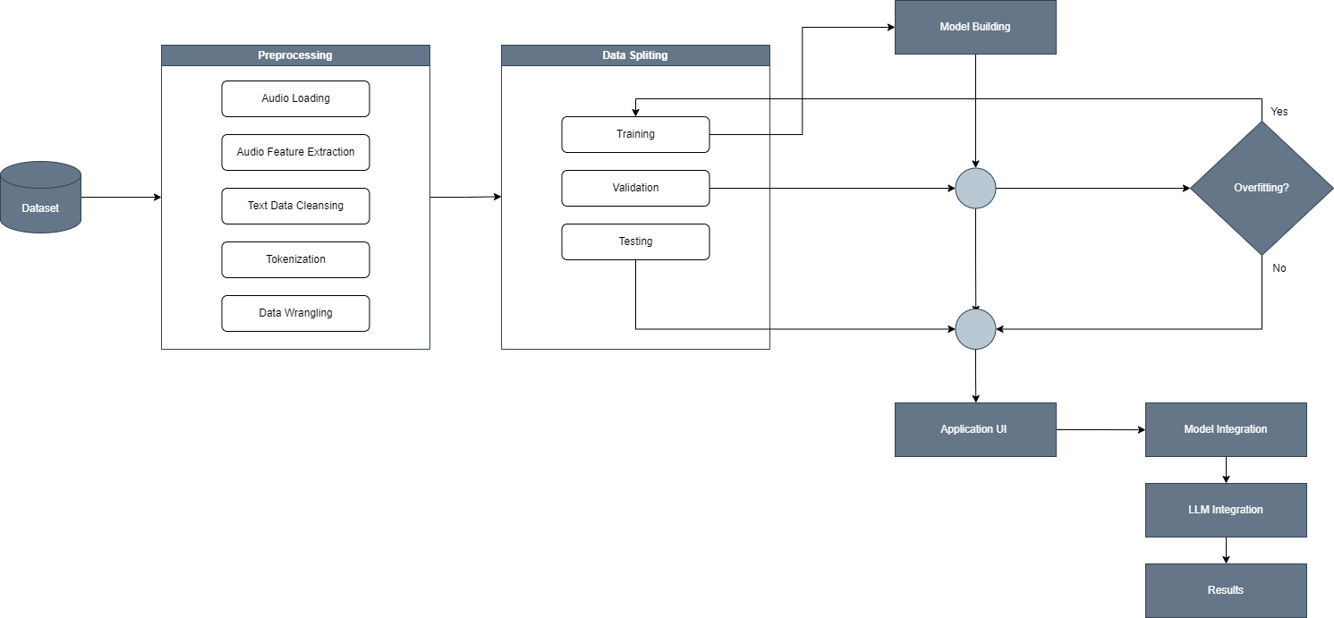
- Methodology
  - Data Collection
Speech Emotion Recognition:
The project utilized multiple datasets, starting with CREMA and SAVEE, which include six primary emotion classes: anger, fear, disgust, happiness, sadness, and neutral. These datasets provided a strong initial foundation for training and testing. However, as the development progressed, their limitations in size and diversity became apparent.
To address this, additional datasets, including TESS, RAVDESS, and EmoDB, were incorporated. This integration enhanced the dataset’s diversity and balance, ensuring better representation of emotions and improving the model’s overall performance.
  - Preprocessing
Speech Emotion Recognition:
The preprocessing stage began with setting up the environment in Jupyter Notebook on my local device. After exploring the datasets, the audio files were organized into subfolders based on their respective labels to facilitate efficient data handling, and then I split the data to 3 sets; training, validation and testing sets.

Signal Processing
The initial focus was on extracting Mel Frequency Cepstral Coefficients (MFCCs) from the audio files. Using 40 MFCC features per sample, a dataset was constructed where each sample was represented by its MFCC features along with its corresponding label. This dataset was used to train a baseline neural network model.

Component | Details
Hidden Layers | Two dense layers: 200 nodes (1st), 100 nodes (2nd)
Activation Function | ReLU
Optimizer | Adam
Loss Function | Categorical Cross-Entropy
Training Epoch | 100
Batch Size | 32
Table 1: The baseline model’s components
This model achieved an accuracy of 40%, which was considered a decent starting point. To improve the performance, pitch features were extracted from the audio data and added to the dataset alongside the MFCC features. The augmented dataset was then fed into the same baseline model; however, this did not enhance the model’s accuracy. In fact, the addition of pitch features slightly degraded performance, indicating that pitch might not be a beneficial feature in this context.
Data Augmentation and Spectrogram Conversion
To address the limitations of the baseline model and improve data diversity, data augmentation techniques were applied to the audio files. This included adding Gaussian noise, pitch shifting, and time stretching, which effectively tripled the dataset size. While this augmentation slightly improved the model’s accuracy, the improvement was minimal. This underscored the complexity of signal processing and its reliance on domain expertise.

To simplify the problem without losing critical information, the audio files were converted into mel spectrograms, which visually represent frequency and time features. The augmented audio files were also converted to spectrograms; however, upon inspection, it was observed that the augmented spectrograms merely duplicated existing data. These duplicates were subsequently removed to ensure a clean and representative dataset.
Figure 1: A mel spectrogram generated from an audio sample. The horizontal axis represents time, the vertical axis represents frequency, and the intensity of color indicates amplitude.
Experimenting with a Pre-trained Vision Transformer
The spectrogram dataset was then fed into a pre-trained Vision Transformer (ViT), specifically google/vit-base-patch16-224-in21k, to leverage its image processing capabilities. Initially, the training process was conducted using the CPU of the local device, but it was exceedingly slow—taking several hours without completing a single epoch.
To address this, efforts were made to connect the environment to the GPU of the local device (NVIDIA GeForce GTX 1650). Despite successfully setting up the environment and connecting to CUDA, the GPU's limited power resulted in training speeds that were still insufficient for efficient experimentation.
As a solution, the project migrated to Google Cloud Platform (GCP), utilizing an NVIDIA T4 GPU on Vertex AI Workbench with Jupyter Notebook. This setup significantly reduced training time, allowing the model to complete 10 epochs. The model achieved an accuracy of 59%, demonstrating that spectrograms were a viable approach.
However, fine-tuning the ViT model resulted in overfitting due to the relatively small dataset size, which comprised approximately 8,000 samples from CREMA and SAVEE. This highlighted the need for either a larger dataset or more robust regularization techniques.
Augmentation with Time and Frequency Masking
To further enhance the dataset and improve model performance, time and frequency masking were introduced. Initially, this augmentation was applied online during training, where either time masking or frequency masking was randomly added to the spectrograms. While this approach effectively introduced variability, it also increased the code complexity and training time.
To simplify the process, the augmentation was shifted offline. This involved pre-generating masked spectrograms, which increased the training dataset size by approximately 30%. However, upon evaluating the ViT model with the augmented dataset, there was no improvement in performance.
A detailed inspection of the masked spectrograms revealed two issues:
- Placement: Most masking was applied to empty spaces in the spectrogram, rather than regions with high intensity, which contain critical information.
- Size: The masks were too large, covering substantial portions of the spectrogram, potentially removing useful information.
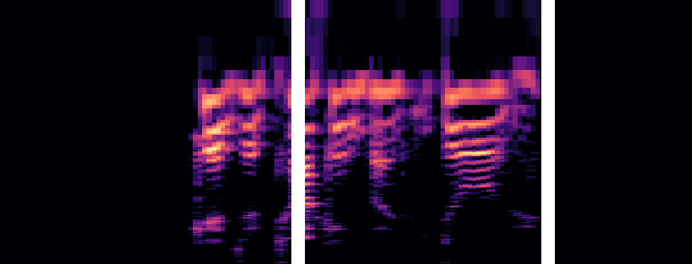
To address these issues, the augmentation process was revised. Energy-based masking was implemented to ensure that masks were applied to regions with significant energy (high-intensity areas) rather than empty spaces. Additionally, the mask size was reduced to avoid excessive data loss. This refined approach resulted in a much better representation of augmented spectrograms, preparing the dataset for more effective model training.
Figure 2: A spectrogram with energy-based masking. The masking is applied to high-intensity regions, ensuring critical information is preserved while introducing variability for training.
  - Techniques
Speech Emotion Recognition:
Vision Transformer (ViT)
Despite the refined preprocessing and augmentation techniques, the ViT model continued to overfit due to the limited dataset size. Attempts were made to mitigate this by freezing the pre-trained layers of the ViT, reducing the number of trainable parameters. However, the model remained overly complex for the dataset, resulting in poor generalization and suboptimal performance.

Convolutional Neural Network (CNN)
To address the limitations of the ViT model, a Convolutional Neural Network (CNN) was implemented as an alternative. The spectrogram images were resized to 256x256 pixels, and a normalization layer was added to scale pixel values, as the spectrograms were represented as RGB images.
The CNN architecture included:
- Input Layer: Resized spectrogram images.
- Convolutional Layers:
  - Four hidden convolutional layers using Conv2D and MaxPooling.
  - Vertical filters of size 5x1 were used in the input and first hidden convolutional layers to capture vertical patterns in the spectrograms.
  - Filters of size 3x3 were used in the subsequent layers for feature extraction.
- Flatten Layer: Flattened the output from the final convolutional layer.
- Dense Layers: Two fully connected dense layers for classification.
- Activation Function: ReLU was used as the activation function for all layers.
- Dropout Layers: Four dropout layers were added with rates of 0.2, 0.3, 0.4, and 0.5 to prevent overfitting.

The CNN model achieved a test accuracy of 56%. While overfitting persisted, it was less severe compared to the ViT model. This demonstrated that a simpler architecture like CNN was more suited to the dataset size and complexity, though further improvements were still required.

  - Post-processing and Hyperparameter Tuning
Speech Emotion Recognition:
Data Expansion and Model Tuning
To address the issue of insufficient data, three additional datasets—TESS, RAVDESS, and EmoDB—were incorporated into the project. These datasets increased the total number of samples by approximately 4,000, significantly enhancing the diversity and size of the dataset. The CNN model was retrained on this expanded dataset, resulting in an improved accuracy of 66%.
Next, a batch normalization layer was added to the model, which marginally increased the accuracy to 67%. However, the improvement was not significant, indicating that batch normalization may not have been the key factor in enhancing performance.

Further modifications were made to optimize the model. The batch normalization layer was removed, and dropout rates were increased to reduce overfitting. The Leaky ReLU activation function was introduced for the convolutional layers to address potential issues with dying neurons. For the final two dense layers, the Swish activation function was applied, and the pixel normalization was adjusted to normalize values in the range of [-1,1]. Additionally, all convolution filters were changed to 3x3, which improved the model’s ability to capture local patterns effectively. After these adjustments, the model’s accuracy increased to 68%.

Confusion Matrix Analysis
A confusion matrix was plotted to evaluate the performance of the model in greater detail. The results were surprising: the model consistently failed to classify any samples as "angry." The "angry" class had both 0 false positives and 0 true positives, indicating that the model could not identify anger in the audio samples. Instead, most of the samples that were actually labeled as "angry" were misclassified as "disgust."
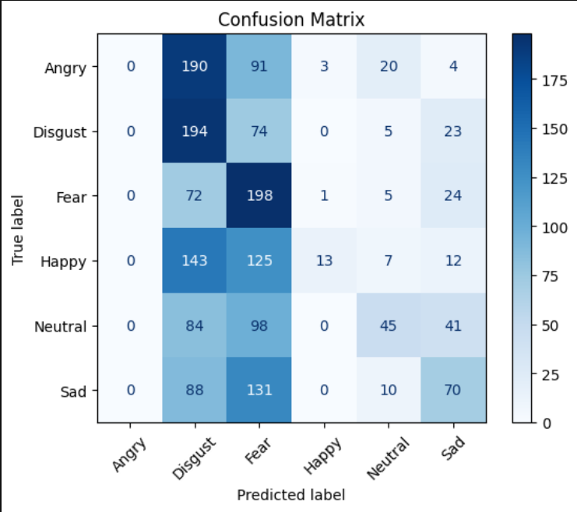
Figure 3: Confusion Matrix for CNN Model. The model failed to classify any sample as "angry," with all "angry" samples misclassified as "disgust."

Class Removal and Accuracy Improvement
During data exploration, it was observed that the "disgust" class had poor-quality acting, making it challenging even for a human to classify the corresponding audio samples accurately. Based on this observation, the "disgust" class was removed from the dataset. This adjustment improved the model’s accuracy significantly, achieving 73%. However, the issue persisted: the model still failed to recognize samples from the "angry" class.

Incorporating Attention Mechanisms
To address the misclassification of the "angry" class, an attention mechanism was considered. Initially, multi-head attention and self-attention layers were explored, but their computational requirements were too high to process 256x256 input images efficiently. As an alternative, Squeeze-and-Excitation (SE) blocks were implemented.
SE blocks were inserted before the pooling layers in the CNN architecture. These blocks allowed the model to focus on more critical features by re-weighting the channel-wise feature maps. After this modification, the model achieved an accuracy of 69%. More importantly, the model successfully classified samples from the "angry" class for the first time, resolving the prior issue of complete misclassification for this class.
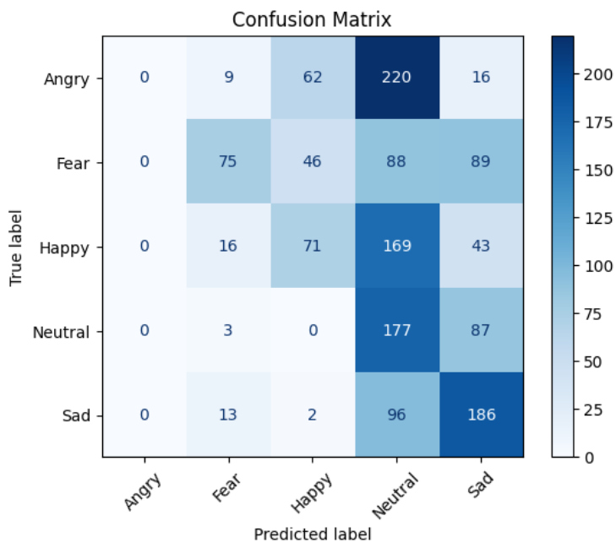  Figure 4: Confusion Matrix Without SE Blocks (Before). The model failed to classify any samples as "angry." | 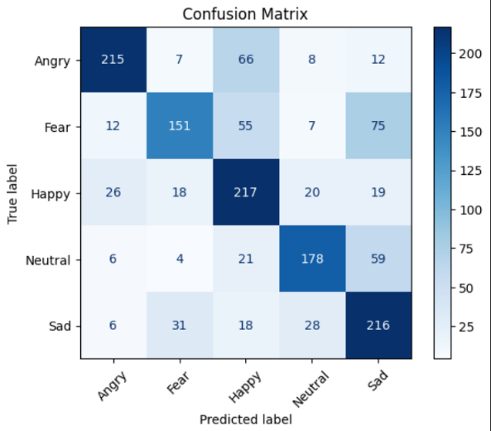  Figure 5: Confusion Matrix Without SE Blocks (Before). The model failed to classify any samples as "angry."
Class Refinement and Custom Loss Function
To further improve the model's focus on key emotions, the "fear" class was removed. This adjustment allowed the model to concentrate on the remaining classes, which were more crucial for the application. With this modification, the model achieved an accuracy of 78% using the SGD optimizer.
However, an issue persisted: the majority of the samples in the "angry" class were misclassified as "happy." To address this, a custom loss function was implemented. The new loss function added a penalty to the loss when the model classified "angry" as "happy." This adjustment improved the model's accuracy to 79% and significantly enhanced its ability to distinguish between these two classes.
An additional penalty was tested to address misclassification of "neutral" as "sad," as this was another recurring error. However, this approach shifted the model's focus away from resolving the "angry-happy" issue, which was more critical. As a result, the penalty for the "neutral-sad" misclassification was removed.

Optimizer Experimentation
Following these refinements, the Nadam optimizer was tested. Nadam, which combines the adaptive learning capabilities of Adam with Nesterov momentum, further improved the model’s performance. The test accuracy reached 80%, with the best classification results observed across all classes.
The final confusion matrix highlights the model's performance after all refinements, including the removal of the "fear" class, the implementation of a penalized custom loss function, and the use of the Nadam optimizer.
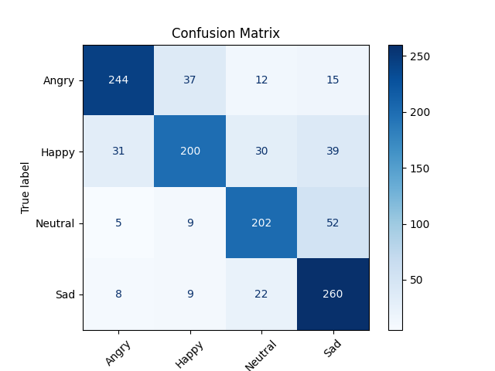
Figure 6: Final Confusion Matrix. The model achieved a test accuracy of 80%, with improved classification performance across all classes, particularly resolving the "angry-happy" misclassification issue.
  - Performance Metric
Speech Emotion Recognition:
The model’s performance was primarily evaluated using accuracy, which measures the proportion of correctly classified samples out of all predictions. Accuracy was used to track the improvements at different stages of model development. Additionally, the confusion matrix was utilized to assess the model's classification patterns and identify where misclassifications occurred.

- Results and Discussion
Stage | Description | Accuracy
1. Initial Test (Baseline Model) | The baseline model, using MFCC features, achieved 40% accuracy. This was the starting point and indicated that further model adjustments and data improvements were necessary. | 40%
2. Vision Transformer (ViT) Model (Before Adding Additional Datasets) | The Vision Transformer model, trained on the augmented dataset, achieved an accuracy of 59%, showing some improvement but still suffering from overfitting and misclassifications. | 59%
3. After Adding Additional Datasets (TESS, RAVDESS, and EmoDB) | After incorporating additional datasets, the sample size increased by 4000 samples, resulting in an improved accuracy of 66%. This demonstrated the benefit of adding more data to enhance the model’s generalization. | 66%
4. After Removing Classes | Removing the "disgust" and "fear" classes allowed the model to focus on the more important emotional categories, resulting in 73% to 78% accuracy. However, the issue of misclassifying "angry" as "happy" persisted, which was a significant challenge. | 73%  78%
5. After Adding the SE Block | Adding the SE block helped reduce some overfitting, and the accuracy improved to 78%. This adjustment allowed the model to better focus on relevant features, though some misclassifications still remained. | 78%
6. After Penalized Loss and Final Model (with Nadam Optimizer) | The final model, which incorporated a custom penalized loss function and was initially trained with the SGD optimizer, achieved 79% accuracy. After switching to the Nadam optimizer, the accuracy further improved to 80%. This change provided the final boost in classification performance, especially in differentiating between challenging emotional pairs like "angry" and "happy." | 80%
Table 2: SER Results
5.6 Product
The Emotion and Sentiment Recognition (SER) application leverages advanced machine learning models to detect emotions in audio and analyze sentiments in text. The application, built using Streamlit, provides a user-friendly interface for individuals and organizations to analyze emotional and sentiment data in real-time. Below, we describe the core components and potential applications of this system.
Introduction to the Application:
The goal of this application is to bridge the gap in communication by helping users understand emotions in spoken audio and sentiments in text. The system is aimed at individuals who struggle with emotional recognition, such as those on the autism spectrum, or any environment where understanding emotional or sentiment context is critical. The models used are trained to classify emotions from speech and sentiments from written text, making the system adaptable for a wide range of use cases, from healthcare to customer service.
Key Features of the Application:
- Audio Emotion Recognition: This feature allows users to upload audio files in various formats (e.g., .wav, .mp3, .ogg). The system processes the audio, extracts features, and analyzes the emotional tone, detecting whether the speech expresses emotions such as anger, happiness, sadness, or neutrality.
- Text Sentiment Analysis: Users can input text directly into the application to analyze the sentiment behind it. The sentiment is classified as negative, neutral, or positive, helping businesses, content creators, or researchers gauge public opinion, feedback, or emotional tone from written communication.

- Limitations.
In SER, although significant progress was made, overfitting persisted despite applying techniques such as early stopping (with low patience) and dropout layers with higher rates. This may be due to the limited dataset size, which presented a challenge for training a robust deep learning model.

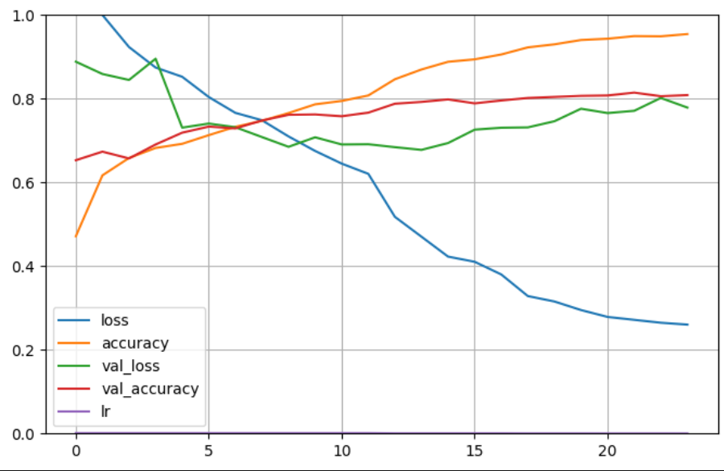
Even though the quality and cleanliness of the data were good, the acting quality in the audio data varied, which contributed to difficulties in classification. Additionally, despite augmenting the dataset and adding more data from other sources, the relatively small size of the dataset was still a limiting factor for the model’s performance.
Figure 7: Training and Validation Loss/Accuracy for the Final Model

Application limitation:
While the application provides valuable insights, there are several challenges and limitations to consider:
- Limited Data Quality: Despite using well-preprocessed data, the models may still face difficulties in accurately classifying emotions due to the inherent complexities in human speech and the diversity of emotions across cultures and languages.
- Performance Limitations: The models trained on relatively small datasets may exhibit overfitting, which affects the generalizability of the predictions. In real-world scenarios with diverse accents, emotional expressions, or informal language, the system may struggle to maintain consistent performance.
- Real-time Processing: While the app is capable of real-time predictions, performance could be further optimized to handle larger volumes of data or provide faster results for more extensive datasets.

- Conclusion

The Emotion and Sentiment Recognition (SER) project successfully integrates deep learning models for analyzing emotions in speech and sentiment in text, providing a valuable tool for various applications. This work highlights the importance of machine learning in understanding human emotions and sentiment, which can be particularly beneficial in contexts like healthcare, customer service, and education.
While the application delivers solid performance, further improvements, such as expanding datasets, enhancing model accuracy, and adding language support, will make it more robust and applicable across diverse scenarios. Ultimately, the project's success hinges on continued iterations, data collection, and model optimization to improve its utility and user experience.
The findings and solutions presented here contribute to the growing field of emotion and sentiment analysis, showing how AI can be applied to enhance human-computer interaction in meaningful ways.

- Future Work
For future improvements in the Speech Emotion Recognition (SER) system, one of the key areas I plan to focus on is the collection of high-quality and diverse data. This is essential for improving the model's generalization capabilities and robustness. Emotional tone can differ significantly not only across individuals but also across languages and cultures. By collecting a large volume of data from various regions around the world, I will ensure that the model is exposed to a wider range of emotional expressions, accents, and speech patterns. This will help mitigate biases related to language or regional variation, which can improve performance in real-world applications.
Additionally, expanding the dataset with more varied emotional categories and diverse speakers will provide the model with better training opportunities. Incorporating more data will also allow for better handling of edge cases and rare emotional expressions, ultimately improving the model's accuracy and reliability.
Another future direction will be the exploration of more advanced models and techniques, such as attention mechanisms and transformers, as well as further optimization of the hyperparameters to reduce overfitting. Experimenting with various audio preprocessing techniques and augmentation methods can also further enhance the model’s ability to generalize from limited training data.

To enhance the accuracy and functionality of the application, the following improvements are suggested:
- Improving Model Performance: To tackle the overfitting issue, additional techniques like data augmentation, larger datasets, or more complex architectures could be incorporated.
- Diverse Datasets: It’s crucial to gather larger and more diverse datasets from various regions of the world to account for cultural differences in emotional expression. This would help improve the model’s generalizability and robustness across different languages and dialects.
- Language Support: Expanding the app’s capabilities to analyze speech and text in multiple languages would make the tool more versatile, allowing it to serve a global audience.
- Real-time Feedback: Enhancing the speed of analysis and providing real-time feedback would make the app more suitable for interactive environments, such as customer support and live interaction scenarios.
- Contextual Understanding: Incorporating contextual understanding (e.g., handling sarcasm, irony, or humor in text and speech) could further improve sentiment analysis and emotion detection, making the system more nuanced and capable of handling complex emotional expressions.

- References
[1] McDuff, D., El Kaliouby, R., et al. (2016). Affective: Emotion AI for Real-time Emotion Recognition.
[2] Kim, J. Y., & Lee, S. (2024). Accuracy Enhancement Method for Speech Emotion Recognition from Spectrogram Using Temporal Frequency Correlation and Positional Information Learning through Knowledge Transfer.
[3] Cai, X., et al. (2021). Speech Emotion Recognition with Multi-task Learning.
[4] Ain, Q. T., Ali, M., Riaz, A., Noureen, A., Kamran, M., Hayat, B., & Rehman, A. (2017). Sentiment Analysis Using Deep Learning Techniques: A Review.
[5] Mrs Snehal Shah1 , Miss Akshata Bhat2 , Miss Sumitra Singh3 , Miss Arya Chavan4 , Master Aryan Singh5(2010).Sentiment Analysis.
- Appendix
Appendix A: Speech Emotion Recognition (SER) Code
- The code includes steps for preprocessing audio, generating mel spectrograms, and applying data augmentation.
- A Convolutional Neural Network (CNN) was used for classification.
Appendix B: Sentiment Analysis Code
- Text data was preprocessed to prepare for classification.
- A Recurrent Neural Network (RNN) with LSTM layers was implemented for sentiment classification.
- The model was evaluated for accuracy and other metrics.
Appendix C: Streamlit Application Code
Note:
The complete code for Speech Emotion Recognition (SER), Sentiment Analysis, and the Streamlit Application is stored in the shared project folder. It can be accessed for detailed implementation and reproducibility purposes.

